

JENKINS INSTALLATION STEPS (UBUNTU)
Step 1: Update the Ubuntu Server
Before installing Jenkins, you have to update software packages on the Ubuntu server for that use the below commands.
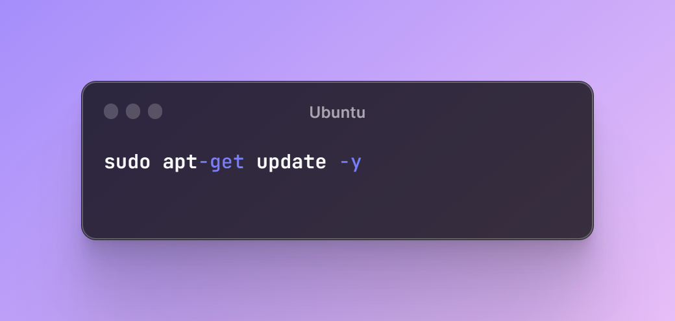
After updating it shows like this.
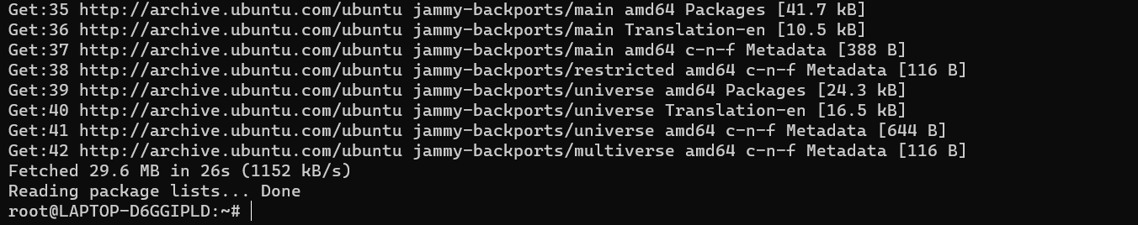

Step 2: Add Repository Key
You have to add the Jenkins repository to the Ubuntu server, use the below command for that.
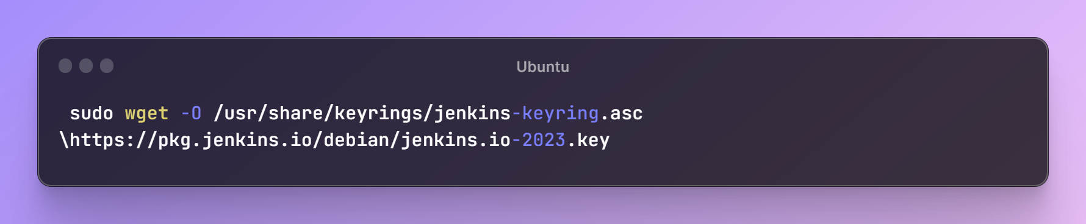
Step 3: Add Package Repository
Use the below command to add the package repository.
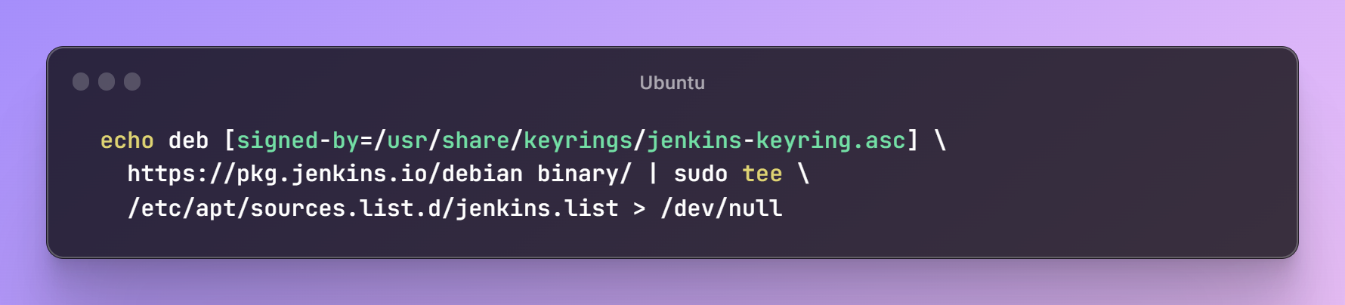

Now, to update the server you have to use the below command.

Step 4: Install Jenkins Dependencies
Before installing Jenkins, we have to install its dependencies. We first have to install java, for that use the below command.
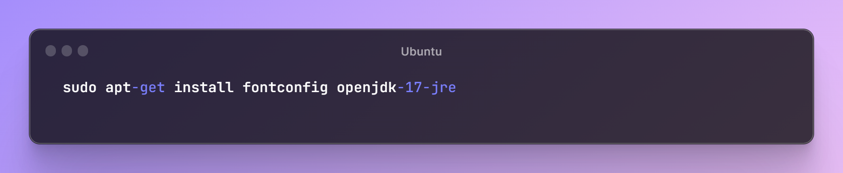
Now, you can use the below command to install Jenkins.
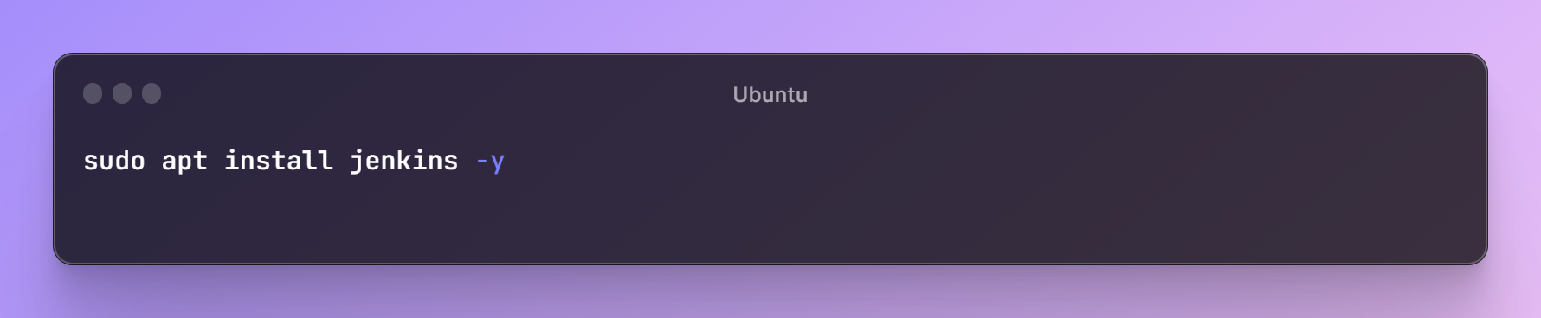

Once Jenkins installation completed you have to start Jenkins service for that use the below command. You can also stop using below.
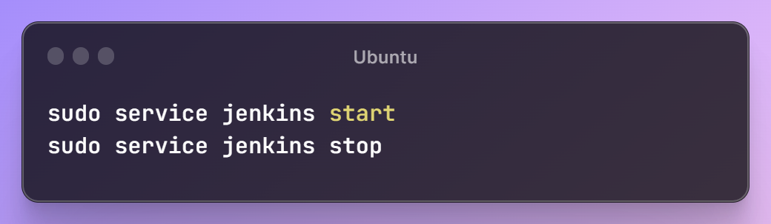

After starting it will show like this.
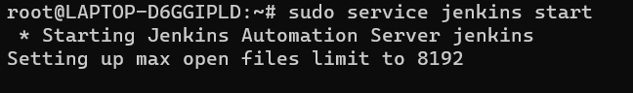

We can also check the status of Jenkins by the following command.
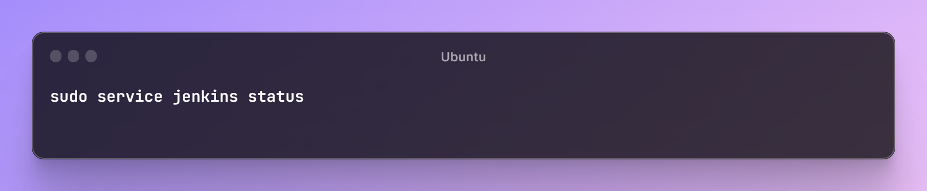
Step 5: Setting Up Jenkins
Now to access Jenkins from the web browser you have to type the below line in URL.
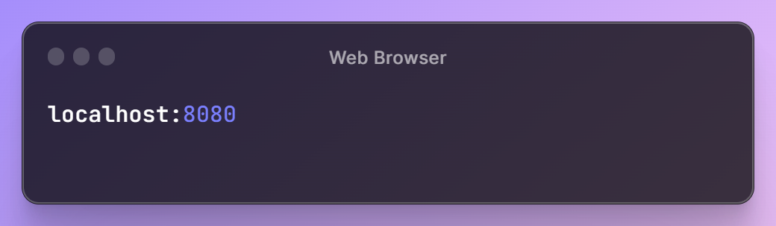

So, after typing the above in the URL we can see the Jenkins Unlock Page.

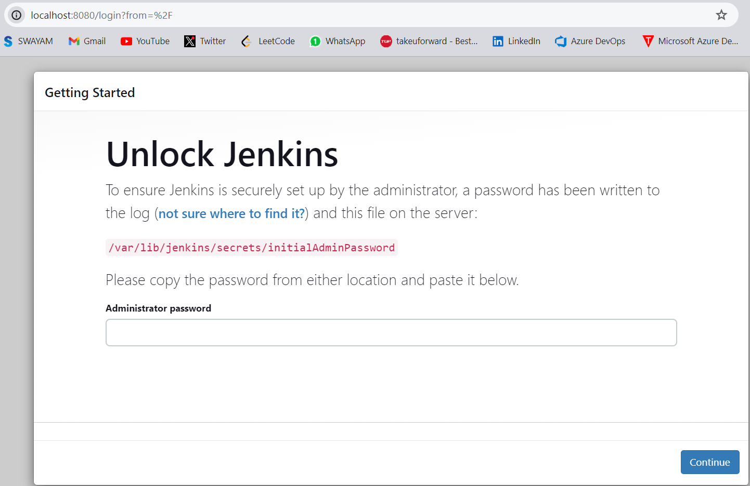

As per the given instructions in the above screenshot, you have to get the default administrator password from the given path so, you the below command to get that on your Ubuntu machine.

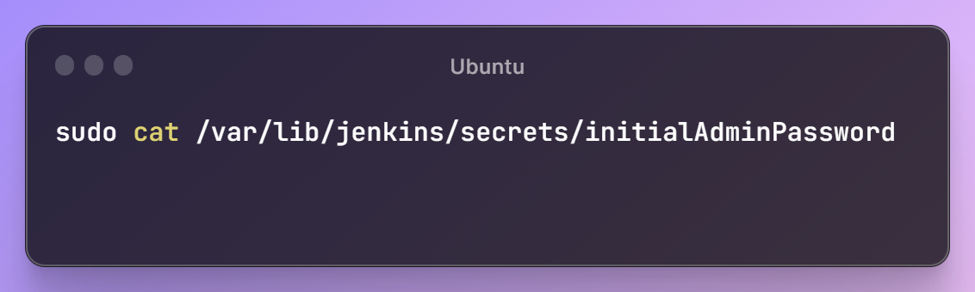

You would get the below output and which is the default admin password for login to Jenkins copy that and use it in a web browser for Jenkins login.

Once you logged in to Jenkins with the default admin password it will give two options and that is suggested plugins and select plugins to install. We recommend you to click on suggested plugins and Jenkins itself takes care of plugin installations. As shown below…
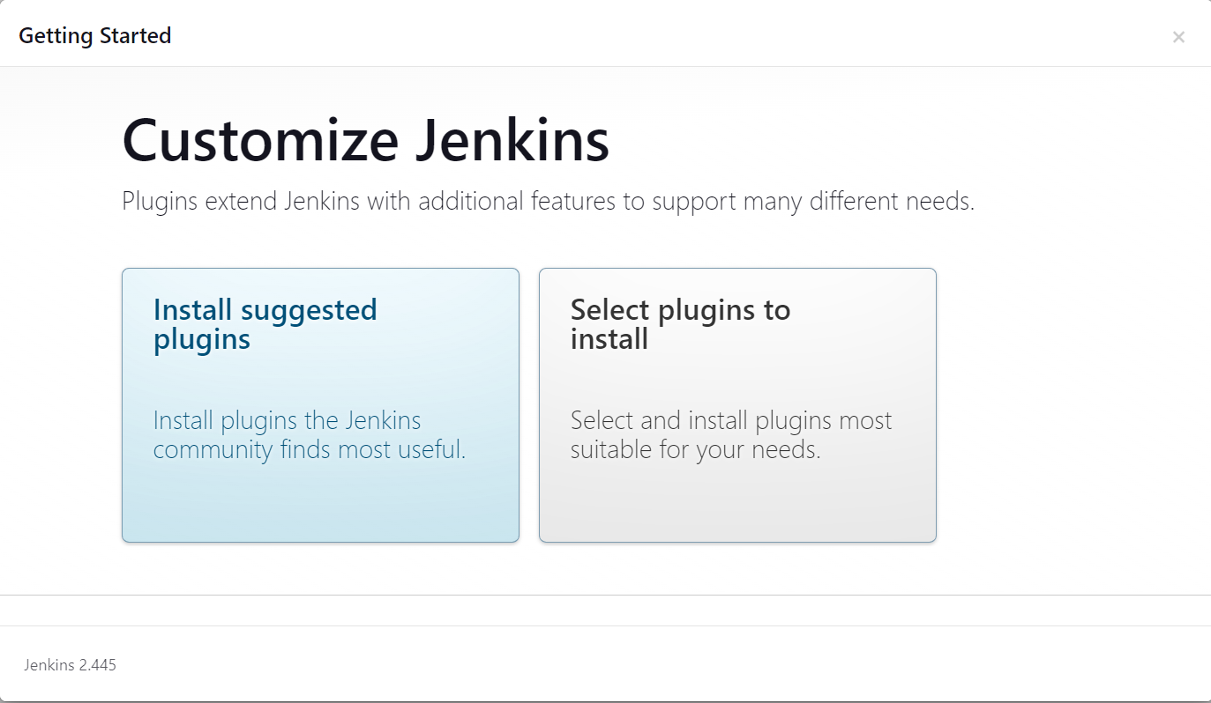

Plugins installation will take some time and once all plugins are installed Jenkins will ask you to create your Admin user account.
Now, fill in the admin user details which you want and set Jenkins admin credentials.
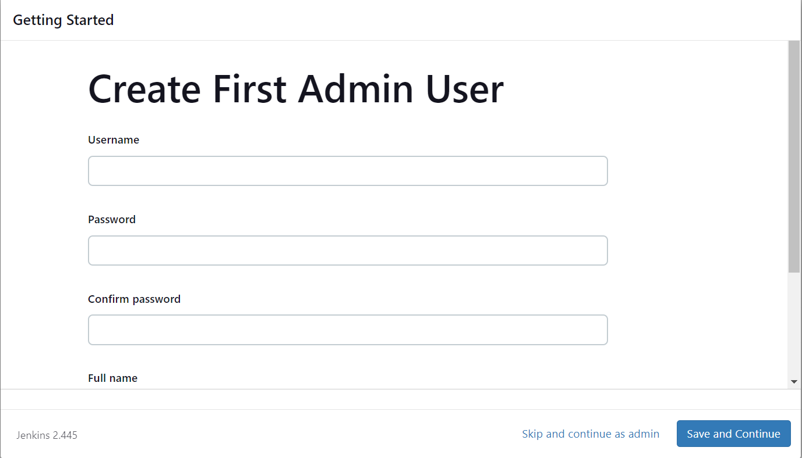
Now friends you get a configuration page and it will ask you to confirm your preferred URL for the Jenkins instance. You can confirm either with the domain name or can use your server's IP address. After setting, Jenkins is ready!
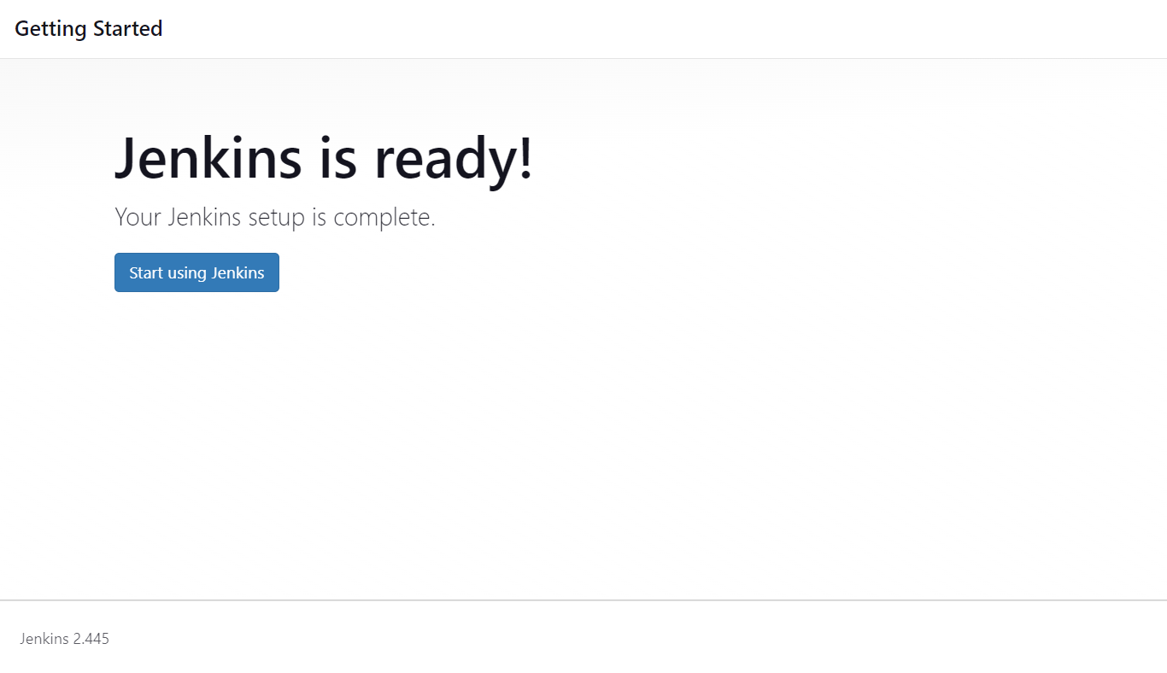
You can log in to Jenkins with created account and start the use of Jenkins.
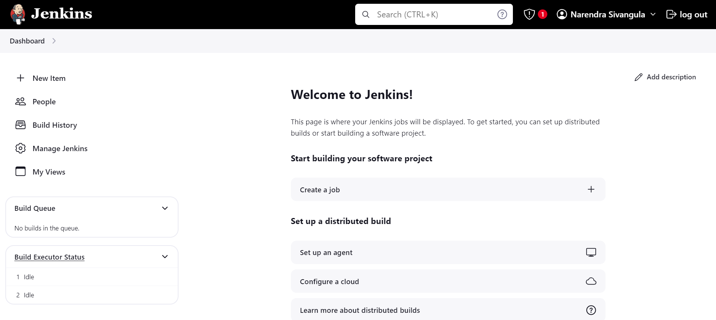

References

Reference: Jenkins.io
Packages & Repositories: https://pkg.jenkins.io/debian/
Installation Blog: https://rishikeshblog.hashnode.dev/how-to-install-configure-jenkins-on-linux-easily

